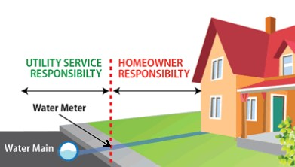

**City of Otterville** is conducting a Lead Service Line Inventory. Part of the inventory is determining the material of the privately owned portion (customer-owned portion) of the service line. Our records are incomplete concerning the material used in the construction of your service line. Because the material of your service line is unknown, it is possible that it could contain lead. Please contact us at **[rsteudle@ottervillemo.gov](mailto:rsteudle@ottervillemo.gov) 660.366.4613** and we can provide you with information concerning the health risks of lead in drinking water, how you can reduce the amount of lead in your drinking water and how you can determine if your service line is made of lead or not. With your permission, we can also assist you with this determination.

***We appreciate your help in completing our lead service line inventory.***